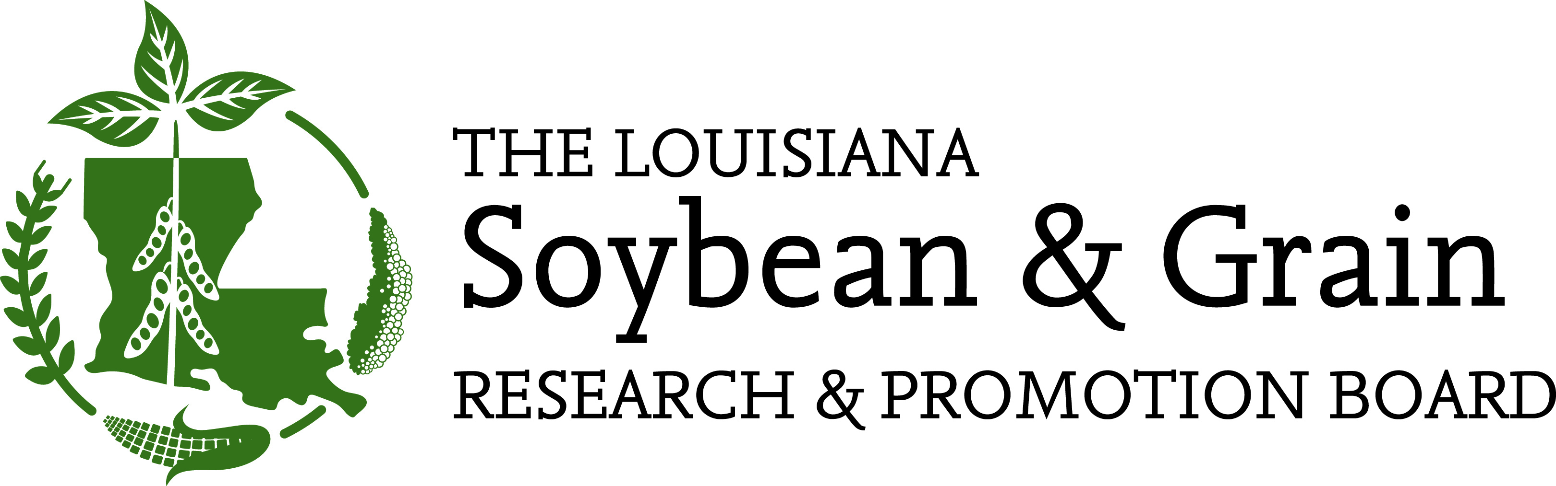

November 4, 2021

TO: Louisiana Soybean and Grain Research and Promotion Board
Charles Cannatella, Joey Boudreaux, Scott Wiggers, Darrell Vandeven, Damian Glaser, Garrett Marsh, Burch Pierce, Joey Olivier, Kellon Lee, Wil Miller, Luke Sayes.

FROM: Charles Cannatella, Chairman

RE: Research Review Meeting Notice

A meeting of the Louisiana Soybean and Grain Research and Promotion Board has been scheduled as follows:
November 18-19, 2021
LSU Campus, AgCenter
Efferson Hall, Room 212
Baton Rouge, LA

The main purpose of this meeting will be to review the accomplishments of each research project conducted during 2021 and look forward to project proposals for 2022. The meeting will start at 8:00 a.m. with introductions, followed by project reviews at 8:30 a.m. After the reviews and presentations are concluded, we will need to conduct a business meeting. Agenda items for the business meeting will include a collections report, a report on fund balances, a report on preliminary assessment (income) projections, and a discussion of funding priorities and projects.

We are bringing back our lunch reception on Thursday the 18th in the Nelson Memorial building for the Board and the researchers to visit informally and share a meal. Please make every effort to attend to hear from our funding recipients and to weigh in on research project needs. If you have any questions or suggestions, contact Andy Brown at 225-922-6209.

CC:AB/jl

cc: Dr. Mike Salassi - LSU AgCenter
Ms. Jenne Farr - LSU AgCenter
Todd Parker - Louisiana Department of Agriculture and Forestry
Mr. Bobby Skeen - Louisiana Cotton & Grain Association

